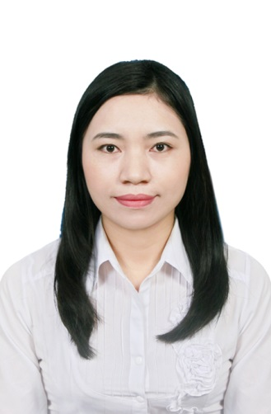
PERSONAL INFORMATION
- Full name : Tran Thi Nhung
- Date of birth : September 17th, 1990
- Mobile phone : +65 8429 9198
- Email : nhungtransp12@gmail.com
MY STRONGEST ABILITIES
- Acquiring quickly. Especially working knowledge
- Having diligent, confident working style
- Soft skills such as communication & team work

CAREER OBJECTIVE
- Being a good customer service officer. I would like to apply the knowledge learnt to real work, study and gain in more working experience.
- Working and learning more things when joining multinational companies to accumulate a lot of experience for the career in future.
- Becoming a professional service manager in the future to develop the best skills of working to benefit for working places and achieve a perfect position.

CAREER EXPERIENCE

The Southbridge Hotel PTE LTD, Singapore  04/2015 – 04/2020 | - Position: Assistant Operation Supervisor/ Assistant Manager  - Working experience: Good knowledge of F&B service, FO service to ensure a smooth running operation of the hotel:  - Job descriptions:  Coordinated duties of hotel departments including Housekeeping, Front Office, Engineering, and Food & Beverage Teams. Ensured employees were performing assigned tasks and reacted to staff & guest needs.  Daily supervision included staffing, training, discipline, scheduling and visually monitoring performance to ensure adherence to all service and productivity standards:  - Supervising and assisting manager the operations of the whiskey bar and restaurant: assigning working stations, training new staffs, doing the reports...  - Handling the front office: completing check in & check out guests, providing information or resolving complaints, collecting payments, reporting...
Van Mieu I Hotel, Hanoi, Vietnam  08/2014 – 03/2015 | - Position: Receptionist  - This position requests necessary responsibilities of a FO staff: communication with guests, monitor front desk matters properly and effectively
Czesc coffee shop, Hanoi, Vietnam  01/2014 – 7/2014 | - Position: Assistant Manager  - Manage day to day shop operations including customer service, payroll, financial reporting, deposits & audits
Movenpick Hanoi Hotel, Vietnam  04/2013 – 12/2013 | - Position: Waitress  - Gaining in more working experience of the F&B staff in a professional and international hotel environment.
Guardian Health & Beauty, Dairy Farm Corporation, Singapore  07/2012 – 01/2013 | - Position: Management Trainee  - This internship program provides standard skills about the customer service of the retailed industry and the management training
- Besides, more experience as a part-timer working in kitchen, restaurant, banquet of international hotels (Crowne Plaza West Hanoi Hotel, Pullman Hanoi Hotel…)

EDUCATION & CERTIFICATION

DEGREES & CERTIFICATES | ISSUED BY
- The Degree of Bachelor in Tourism Studies  Specialization /Major: Hospitality | University of Social Sciences and Humanities, Vietnam National University, Hanoi (2008 - 2012)
- Certificate of completing the training skills | Center for Cooperating and Transferring Knowledge, Vietnam National University – Hanoi (05/2012 - 06/2012)
- Certificate of completing working period as a management trainee | Guardian Health & Beauty, Dairy Farm Corporation, Singapore (07/2012 - 01//2013)
- Certificate of Follow Food & Beverage Safety and Hygiene Policies and Procedures | Guilford Training Centre, Singapore (04/2016)
- Advanced Diploma in Hotel and Restaurant Management | GEA Institute, Singapore (07/2018 - 08/2019)

LANGUAGE & SKILLS
- Language: Vietnamese, English (good)
- Studying and researching independently and effectively
- Sociable, enthusiastic, ambitious and willing to study
- Team work, leading skills, computing skills (experience in Microsoft Office-Word/Excel/PowerPoint and Hotel Management Software)
- Interested in social activities: voluntary work, outdoor sports like football, badminton

